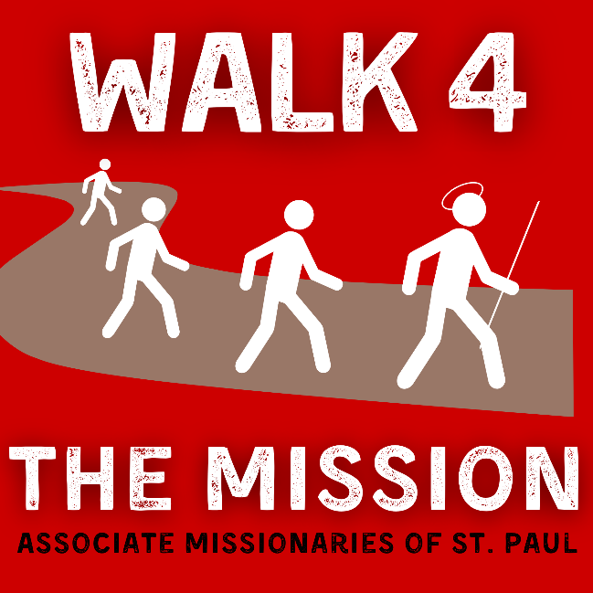

FIFTEENTH ANNUAL WALK-A-THON
Saturday, May 16, 2026
8:00 AM (sign-in/on site registration); 9:00 AM (Walk)
Tom Bass Regional Park
15108 Cullen Blvd. Houston, TX 77047
Pavilion 4
To benefit educational empowerment provided by the
Missionary Society of St. Paul

To benefit educational empowerment provided by the
Missionary Society of St. Paul

This walk-a-thon will help raise funds to empower weak and disadvantaged young people in Africa with whom the Missionary Society of St. Paul, a 501(c)(3) non-profit organization, serves.
Our efforts, are focused on empowerment through education. These efforts have included building community schools, providing food and clothing and subsidizing school tuition for children to attend school, as well as providing care for children orphaned through the devastating effects of AIDS.
Specifically we would like to provide books, computers and clothing and continue building schools and providing orphans with food and shelter.

This walk-a-thon will help raise funds to empower weak and disadvantaged young people in Africa with whom the Missionary Society of St. Paul, a 501(c)(3) non-profit organization, serves.

Please see registration on the reverse side or go to www.mspfathers.org and click on Walk-A-Thon to register online

WALK 4 THE MISSION

REGISTRATION FORM
REGISTRATION FEE $20.00 (Adult); $10.00 (Children)
MAIL TO: MSP, 3607 Meriburr Lane, Bldg. A, Houston, TX 77021-1309
Email: usamsp@yahoo.com Phone: 713-747-1722

Name ___________________________________________________ Team: ____________________________
Address____________________________________________________________________________________

_________________________________City/State/Zip _______________________________________
Phone ___________________________________________ Email ____________________________________

T-shirt size (check one) ____S ____M ______L ___ XL Child: _____ M ______ L
Register by March 14, 2012 to guarantee an official T-Shirt.

Name of Supporter | Address | Donation Received | T- Shirt size | Other pledges
Please note: T- Shirt sizes = Children M & L, Adult = S, M, L, XL, XXL
Attach separate sheet for more sponsors Complete and return by May 1, 2026, to be guaranteed a t-shirt
MAKE CHECKS PAYABLE TO: MSP MISSIONS

SPONSORSHIP: I/My business/my employer whose name shall be recognized as:
________________________________________________________ wishes to be a sponsor as below:
(circle all that apply and return by May 1, 2026)

Platinum Sponsor: Donation of $2,500.00
Gold Sponsor: Donation of $1,250.00
Silver Sponsor: Donation of $750.00
Bronze Sponsor: Donation of $500.00

ACCIDENT WAIVER AND RELEASE OF LIABILITY
I understand that my participation in the “Walk 4 the Mission” Walk-a-thon is voluntary and at my own risk. Under no circumstances will the Missionary Society of St. Paul, its staff, directors, volunteers, or its Associates be responsible for any injury or damages incurred by me or my property. I agree to permit the free use of my name and picture in any broadcast, telecast, or other account of this event.

Name: ___________________________________________________________ Date: ____________________________

Signature: ______________________________________________________ [If participant is under 18, Parent’s or Guardian’s signature]

How did you learn of the WALK A THON?
□ AMSP Member or Friend □ Catholic Herald □ Church Bulletin □ Visitor at Church / Bazaar □ Pastor □ Other ___________________________________________

